Solidarity Co-operative Summit Event Report
Manchester, October 2017

About the organisers

Co-operative Business Consultants (CBC) is a co-operative consortium of individuals and organisations committed to social justice through solidarity co-ops operating in the UK and Ireland. For over a decade they have built a solid reputation for providing high quality services to co-ops, working with many start-ups as well as existing businesses. CBC is active in finding new ways forward and promoting democracy and accountability within the co-operative movement.

Solidarity Economy Association (SEA) (formerly the Institute for Solidarity Economics) is a multi-stakeholder co-operative working to support the growth of the solidarity economy movement in the UK - an economy that embodies the values of economic and social justice, diversity and pluralism, co-operation, self-management, and ecological sustainability.

About the event

For the past four years, CBC have been hosting the Ways Forward conference series as a way of bringing together co-operators, trade unionists and activists from anti-austerity parties and social enterprises to discuss and debate co-operative and radical alternatives to austerity and capitalism, and to help shape a vision of a prosperous, caring society based on a democratic economy. The conferences have been very successful in bringing people together, and in recent years have seen high profile speakers including shadow cabinet members John McDonnell MP, Rebecca Long-Bailey MP and Angela Rayner MP, Green MEP Molly Scott Cato, former Co-operative Group CEO Sir Graham Melmoth, filmmaker Ken Loach, Preston City Council's Matthew Brown, Co-operatives UK CEO Ed Mayo, and many more.

Solidarity Economy Association has been an active supporter of Ways Forward for several years, and the two organisations decided to collaborate on taking the Ways Forward conference activity to the next level by holding a summit on the topic of solidarity co-operatives - provisionally defined as being co-operatives which make a serious commitment to actively pursuing all of the ICA’s values and principles.

The aim of the event was to test the appetite for finding or creating vehicles for the focus and energy generated at the Ways Forward conferences to be sustained throughout the year, and to catalyse larger projects. Its focus was on bringing together a small group of like-minded people and organisations to discuss some of the most pressing issues facing the co-operative movement in the UK, and to assess whether there was need and/or demand for the formation of a network of some kind, which would work together on tackling some of these pressing issues.

Session 1 - Welcome and Introductions

After introductions and welcome, all eighteen attendees shared their hopes for the day and explained briefly why they had chosen to attend. The most often-repeated or agreed-with reasons were:

- To take forward the discussions from the Ways Forward conference
- It’s an opportunity to think about the long-term strategy for our movement, and address the needs we have that aren’t currently being met
- Because solidarity economics politicises co-ops, it’s important to discuss the ways in which co-ops are vehicles for social change
- To take forward action, as well as words
- To build bridges between similar-minded organisations and individuals

It was clear from this session that whilst capacity is likely to be an issue for some people, everyone was open to finding new ways for co-operatives to collaborate, either in terms of providing mutual support, or by working together on new activities or projects which would have wider societal and environmental benefits.

Session 2 - What are the shared needs and challenges of our sector?

This open session stimulated a lot of discussion, and it was clear that there are many opportunities for collaboration, in order to meet the shared needs and challenges of our sector.
The needs and challenges identified by the attendees are:

- Defining / protecting the co-operative brand
- Raising awareness of co-operatives outside the movement, and highlighting the variety of co-ops that exist
- Co-operative development
- Co-operatives in different sectors of the economy
- Lack of coordination
- More co-operation between co-operatives
- Central federal bodies within sectors, for example co-operative community transport (where those setting up these kind of co-ops could seek support, advice, resource)
- Encouragement to be bolder, for example within social enterprise
- Building cross-sector collaboration
- Effectively articulating why co-ops exist, their values, and what sets them apart from other forms of business - “Co-ops as enterprises for the common good.”
- Creating a culture of co-operatives, for example through artistic endeavours
- The need to address the question together of whether we see co-operatives as an alternative to the current economic system
- Public policy that nurtures co-operative development
- Co-operative movement taking advantage of the free software movement
- Capital
- Education on our wider values, co-operative movement’s history
- Links between the trade union movement and the co-operative movement
- Networking - geographic as well as sector
- Co-operative education, for example schools

We grouped this long-list into four main themes, reproduced below.

Shared needs of co-operative sector

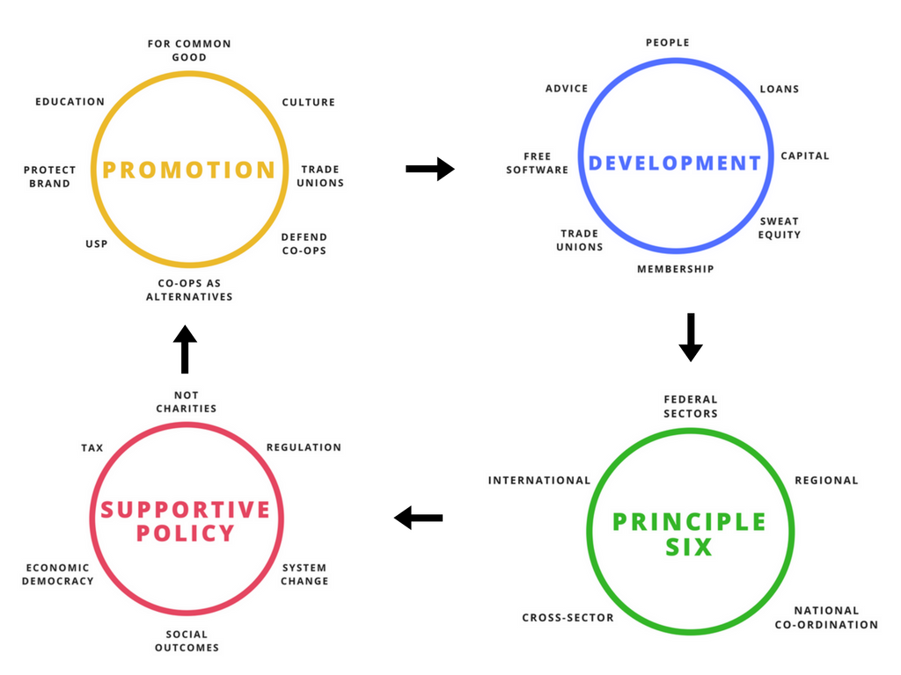

Session 3 - What are ‘solidarity co-operatives’?

3.1 Worldview
This session was introduced with an overview of what the term ‘solidarity co-ops’ means around the world, where it is in much higher usage than in the UK, with a history of and background to the Social and Solidarity Economy (SSE) Movement around the world. There was also a brief discussion about the difference between social and solidarity initiatives, with many seeing social co-operatives as being part of a bigger ring of solidarity co-operatives. More information about this can be found on RIPESS Intercontinental’s website here - http://www.ripess.org/

3.2 Contextual issues
We discussed some of the wider contextual issues within parts of the UK co-operative movement, particularly around the reputational damage that has been done to the co-operative brand by the Co-operative Bank. The question was posed as to whether there is a need for solidarity co-ops to challenge the things we see as damaging issues within the movement, or whether we focus on reclaiming the brand and repositioning it. Some felt that there was a need to do both, and that there is real energy behind building alternatives, for example ‘true’ co-operative banks. It was clear that there was a strong desire within the group to focus on positive change, whilst not turning in on ourselves or splitting the movement, and to focus on having the most effective debates and policies. Some see the Co-operative Bank as the context within which we are working, not what we should be focusing on changing specifically.

It was also pointed out that mutuality grows when times get tough, and that there is in the UK a glaring need for solutions to the societal crises we are currently experiencing, which co-operation can help to provide. It was also raised that the Labour Party has been increasingly supportive of co-operatives and that the wider context of the recent general election means there is an opportunity to capitalise on the growing momentum and desire for change.

3.3 Looking ahead
Several people put forward the view that an important focus for solidarity co-operatives should be on action learning, and inspiring a new wave of co-operative development, reaching out to new audiences and sectors and providing mutual support.

The point was reiterated that it was important to work on building the alternatives, rather than challenging head-on the individual instances we have issues with, and to focus on positive, proactive marketing to encourage people to share solidarity co-operative values.

It was felt that it was important to recognise that all co-operatives are on a journey, and not to alienate anyone working hard to create something they believe in, but which may not have reached their ideal destination yet.

It was suggested that promoting horizontal networking among smaller co-operatives is critical, and that introducing a member cap on individual co-operatives should be seriously considered, so that the individual co-ops can remain small and focused, but benefit from much wider, horizontal networks, like the Mondragon and Emilia-Romagna examples. This would also allow solidarity co-ops to focus on membership participation, which, it was felt, is being lost.

3.4 Our definition
It was agreed that it was important for the UK to make the definition our own, within our own context - in a way that is consistent with the rest of the world, but that works for our own needs, too.

We agreed that the fundamental element of solidarity co-operatives would be a meaningful commitment to taking all of the ICA’s values and principles seriously; whilst not all solidarity co-operatives will necessarily be excelling at all of them, they will demonstrably be working towards it. In addition, there was also agreement that working towards environmental sustainability, and towards system change, are important factors.

The desire for a proactive approach was also clear within this session, with many agreeing that being a solidarity co-op is about empowering people to create something together, rather than existing as a benevolent organisation which ‘does good’ to its community or society.

It was noted that some people use the terms ‘solidarity co-ops’ and ‘multi-stakeholder co-ops’ interchangeably, but it was felt that this would be too restrictive for the UK context.

Everyone agreed that whilst words and definitions are important, we must be aware that they will always be understood differently by people in different contexts, so we are unlikely to reach a definition which means the same to everyone. The important thing is to agree it initially, and focus on the activity we want to do and the change we want to make.

At the end of this session, it was suggested that rather than a ‘solidarity co-op network’, what was needed was a ‘co-operative solidarity network’. This was received favourably, as it was felt it embodied action in its title, and the change in word order meant that it focused on the ‘doing’ of solidarity, rather than the who or what that made up the network.

Session 4 - Projects and vehicles to meet our shared needs

The aim of this session was to look at some of the potential projects or activities that a network could work on together. This took the form of a brainstorming session, during which there were a number of ideas put forward, including people sharing some of the things they are individually working on, which could become collaborative efforts. There was a balance between grassroots activity, and efforts such as influencing policy at a national level. These have been grouped below under the themes which resulted from session 2.

Promotion:
- A piece of work positioning co-operatives as helping people to feel reconnected to their communities and their places again, as an answer to Brexit. Promoting local control through co-operatives, and to saving and creating the community in which people want to live, through cross-sector collaboration - for example, co-operative pubs, shops, libraries, breadfunds, credit unions, etc.
- Giving people the tools and training to become passionate, proactive advocates for the co-operative movement, linking sectors and organisations
- Education is a fundamental need and should sit across all the themes
- Is co-operativism an answer to capitalism? There’s a gap in the link between co-ops and economic systems, so there is a need for the thinking, research and analytic pieces that help people to see co-operatives as the vehicles for wider systemic change. We need to be mindful of linking in with others, for example the UK Society for Co-operative Studies.
- There’s a need for a conference or coming together to focus on co-operative economics in an inspiring way

Supportive Policy
- If co-operatives are going to flourish, there is a need to influence the creation of policies which will help this to happen and to engage with political parties.
- The creation of a channel for co-op practitioners to feed into policy creation, e.g. via the Labour Party

Development
- Finding a way to unlock our shared resources to build the movement - how is this structured co-operatively?
- Creating tools and resources that help co-operatives engage more widely within their communities and with different institutions (such as schools and local authorities) (links with Promotion)
- Creating peer-to-peer support networks and mentoring
- Recognising that co-operative development needs to take place within communities - the idea of a roadshow or festival of co-operative ideas and support which is created and then shared with communities to create their own versions, so that it responds to their own needs, but helps them to do it.
- A solidarity fund for the whole movement, not just worker co-ops (e.g. SolidFund) - this could either be a central fund, or sector-specific
- Could a ‘project soup’ style event be created, or held as part of the next Ways Forward conference, to support solidarity co-ops?

Principle Six:
- Building a mechanism to pool resources within the movement, to come together and be resilient
- Finding a way to develop confederation within the co-operative movement
- Overcoming barriers that exist between different areas of our movements, ignoring (small ‘p’) politics and engaging with people in a fresh and open-minded way to create new partnerships and projects - making links as if you are new to the movement and open to everything!

Proposals and Working Groups

1. Ways Forward 6 Conference
The creation of another summit or event on the same theme was proposed, and several organisations expressed an interest in co-organising an event. Working group to date: SEA; Students for Co-operation; CBC.

2. Creating an online means of communication and visible presence for the Network
One organisation offered to create a way of communicating online via Discourse or another similar platform to help conversations and discussion to continue. They also offered to create a simple Wordpress website if/when it is decided a visible public profile is needed. There may also be a need for a Facebook page to act as a shared noticeboard, so that people can post things of potential interest to the wider group. Working group to date: Web Architects; SEA.

3. Co-operative policy development
Some people and organisations would like to work together to develop policies on co-operatives that could be implimented by a Labour government. Working group to date: CBC; Anthony Collins solicitors; Students for Co-operation; Tom Wilkinson, Radical Routes; SEA.

4. Continuing to develop the idea of a Co-operative Solidarity Network
CBC and SEA have committed to continuing to facilitate discussions, to communicating regularly with the attendees of the summit, and to think through what the next steps might be for opening the idea out to a wider audience.

Conclusion and Next steps

Attendees said the Solidarity Co-op Summit stimulated some important debate and discussions. In order to continue the momentum, the next steps will for the working groups to focus on their activity. If you or your organisation would like to commit to one of the working groups above, or would like to propose a new one, please let us know.

kat@solidarityeconomy.coop jo@cbc.coop

